

User Guide Report

Dime-Personal Finance Management

Lecturer:

Dr.

|  |  |
| --- | --- |
| **Name** | **Matric ID** |
| Muhamad Firdaus bin Janon | WIF160026 |
| Muhamad Syafiq bin Romli | WIF160027 |
| Mohammad Saufei bin Iberahim | WIF160020 |
| Danial bin |  |

Chiam Yin Kia

**USER'S MANUAL**

**TABLE OF CONTENTS**

1. **GENERAL INFORMATION**
   1. System Overview
   2. Organization of the Manual
   3. Contingencies
2. **SYSTEM SUMMARY**
   1. System Configuration
   2. User Access Levels
3. **USING THE SYSTEM**
   1. Download
   2. Index
   3. Login and Signup
   4. Main menu
      1. **Profile**
      2. **Dashboard**
         1. Summary of Expenses By category
      3. **Manage Goals**
         1. Add, Edit, Delete Goals
      4. **Manage Expenses**
         1. Add, Edit, Delete Expenses
      5. **Logout**
4. **SUMMARY**
5. **GENERAL INFORMATION**
   1. **System Overview**

Dime is a web application for Personal Finance Management. This web application contains features like: Home page – display information about the website, messages or news. User registration and log in – allow users to create new user accounts and log in to their user account to manage their personal finance. Set personal finance goals – allow users to set saving goals and plan to achieve the goals o e.g. saving goals – saving money for something important like further studies in overseas, travel the world, buy a house o e.g. plan to save RM500 per month. Manage daily expenses - allow users to set monthly budget/income; add, edit, delete every transaction (date, amount, category of expenses) that they have made o Expenses should be added by category (e.g. groceries, food, transport, shopping, entertainment). Month expenses report with charts – allows users to see the summary of their monthly expenses, for example: o summary of expenses by category o budget/income vs actual expenses

* 1. **Organization of the Manual**

These user’s manual consist of 4 section: General Information, System Summary, Getting Started, Using the system. General information section explains in general terms the system and the purpose for which it is intended. System summary section provides a general overview of the system. The summary outlines the uses of the software requirement, system configuration, user access levels and system behaviour in case of any contingencies. Getting started section explains how to get DIME work. The section present briefly system menu. Using the system section provide a detailed description of system functions.

1. **SYSTEM SUMMARY**
   1. **System Configuration**

DIME operates on any web browser, on any operating system, The application requires connection to internet in order to save data to database. The application can be use immediately without any further configuration.

* 1. **User Access Levels**

Everyone can use this application, but only registered users are able to use the feature of this application and save data to the database.

* 1. **Contingencies**

In case of power outage data are not saved in internal memory of the operating device (except photos that are stored in external storage folder of the device). In case there is no Internet connection available data cannot be saved in internal memory of the operating device.

1. **USING THE SYSTEM**
   1. **Download**

This application can be download at zzzzzzzzzzzzzzzz

* 1. **Index**

Once the user run this web application this window will come out.

Figure 1

This index window (Figure 1) consists a navigation bar with LOGIN and SIGN UP button. In this window we listed the feature that user can get by using this web application. We also put another button for LOGIN and SIGN UP in blue colour to make it easier to distinguish by the user. The user can interact to its specific features.

* 1. **LOGIN and SIGNUP**

1. **SIGN UP**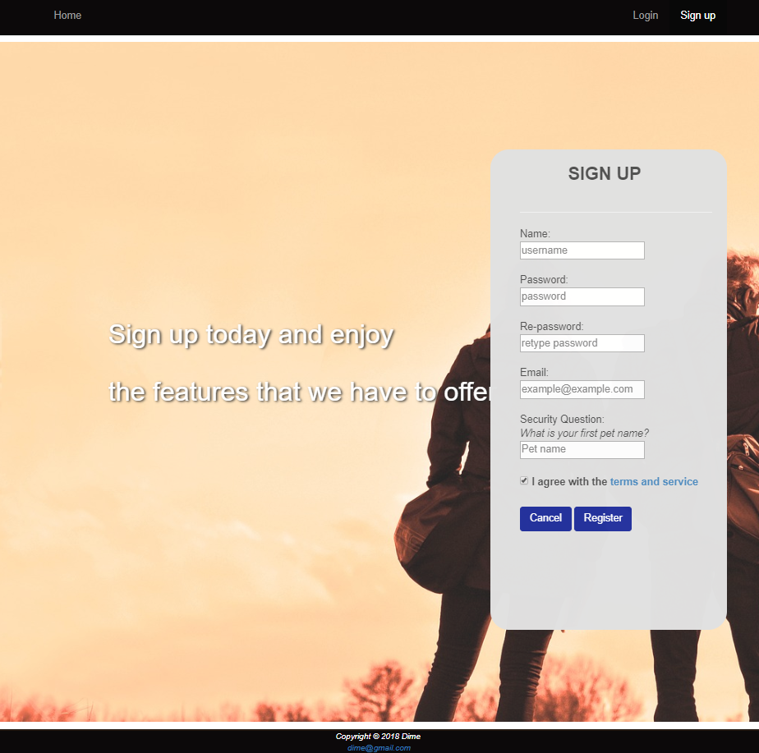

Figure 2

The SIGNUP page (Figure 2) consist of 5 input field form which is Name, password, re-password, email, and security question. User need to click register button after completing the form to complete the registration process. If user want to cancel the registration they can click cancel button. If user enter an existing username the user will be notify and have to enter another unique username. It is the same for email. For the password if the use rre enter a unmatch password the user need will be notified that he/she need to match the password.

1. **LOGIN** 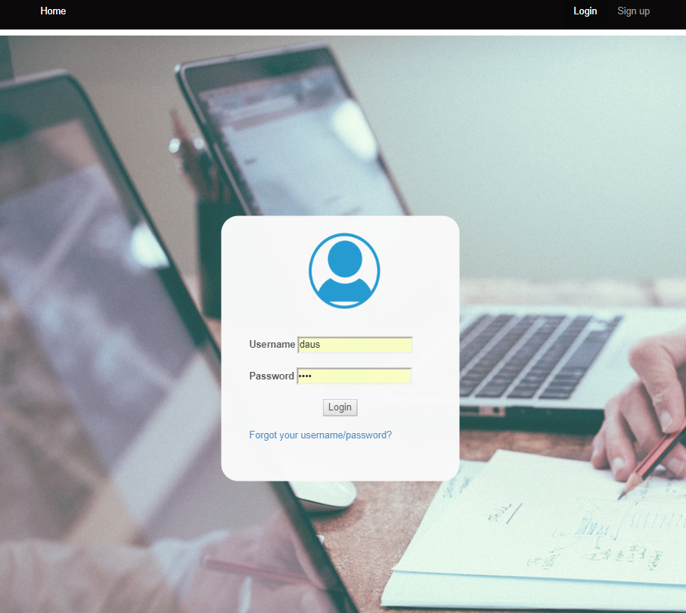

Figure 3

Figure 3 is the login page, user can login after they complete the registration process. User need to input their username and password to login. If they forgot to login they can click (Forgot your username/password). At there user can change their password by entering correct security answer that are provided.

**C.FORGOT PASSWORD**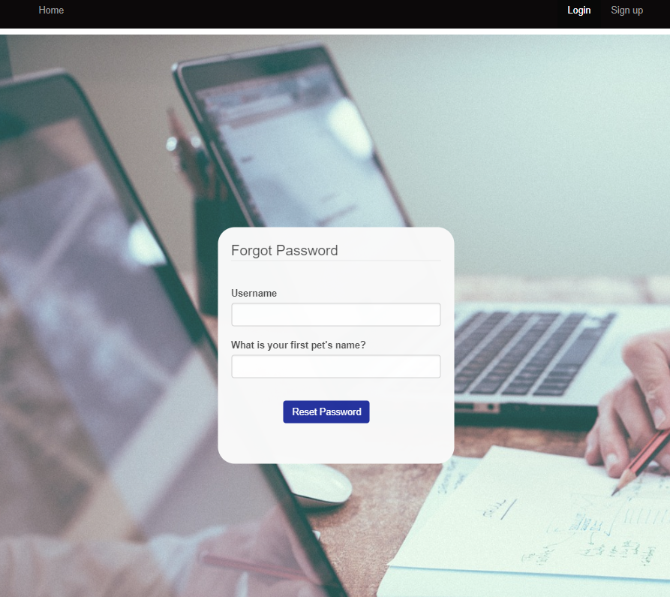

**Figure 4**

Figure 4 show the Forgot page tab, this page contains 2 input field, user need to enter their username and the security code to reset their password. If one of the field is wrong then red notification word will appear saying “Username does not exist”. If the user forgot the security answer, he/she need to contact administrator to recover their account.

* 1. **Profile**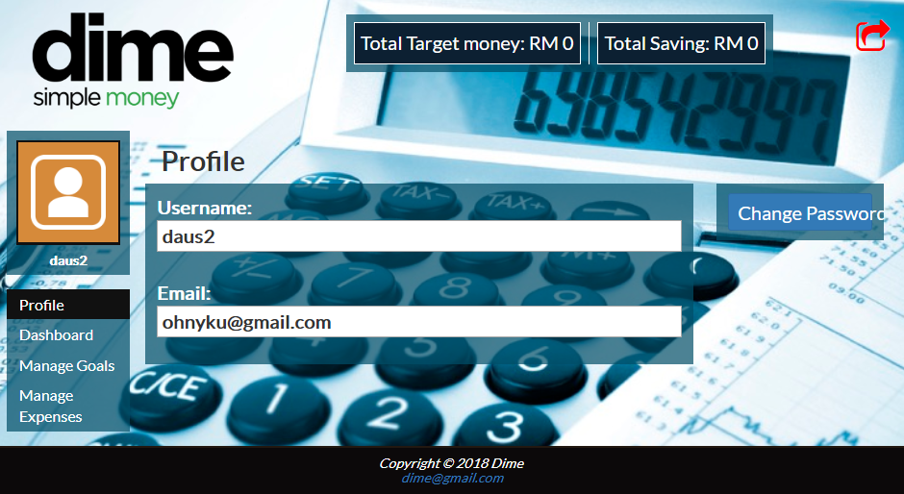

**Figure 5**

Figure 5 is the profile page, here user can view their username and email. User also can change their password by clicking the “change password” button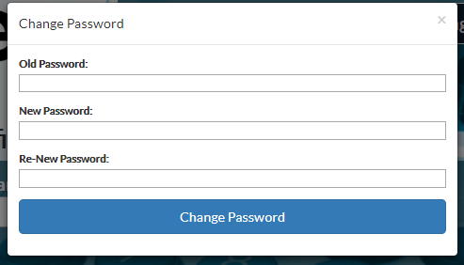

**Figure 6**

Figure 6 is the change password window, it will appear when user click the “change password” button. There’re 3 input field which is old password, new password and re-new password. User is advice to change password regularly.

* 1. **Main Menu**
     1. **Profile**

**Figure 5**

Figure 5 is the profile page, here user can view their username and email. User also can change their password by clicking the “change password” button

**Figure 6**

Figure 6 is the change password window, it will appear when user click the “change password” button. There’re 3 input field which is old password, new password and re-new password.

* + 1. **Dashboard**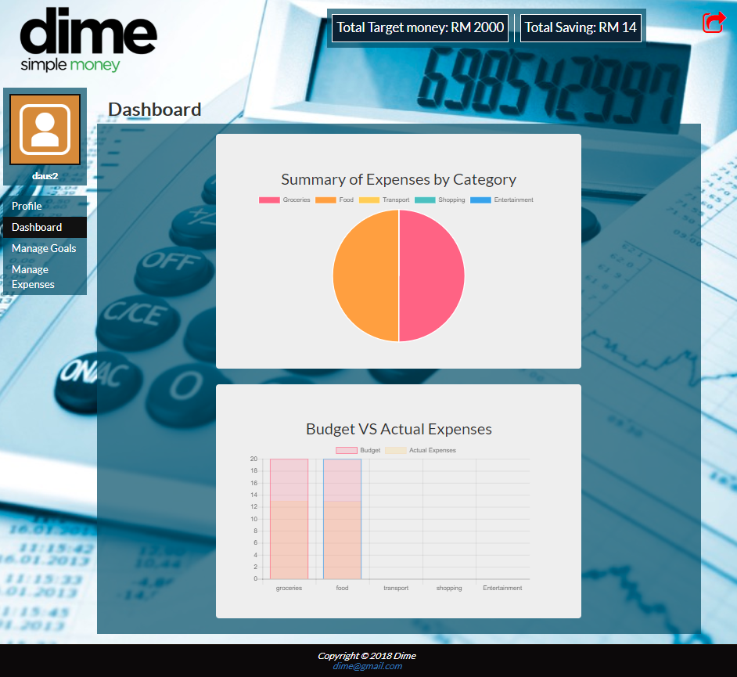

**Figure 7**

Figure 7 is the dashboard page, this page will show the pie chart of summary of expenses by category (user can hover the mouse to view the value for each category). Below the pie chart there is a bar graph that show the budget vs actual expenses by category(groceries, transport, entertainment, food and shopping). Firstly, User need to enter data on date, category, actual expense and their budget on the manage expense. Thus, the info on the total amount of spending will be generated and show on the dashboard in the form of pie chart and bar graph. Chart.js is used to display chart/graph.

* + 1. **Manage Goals**

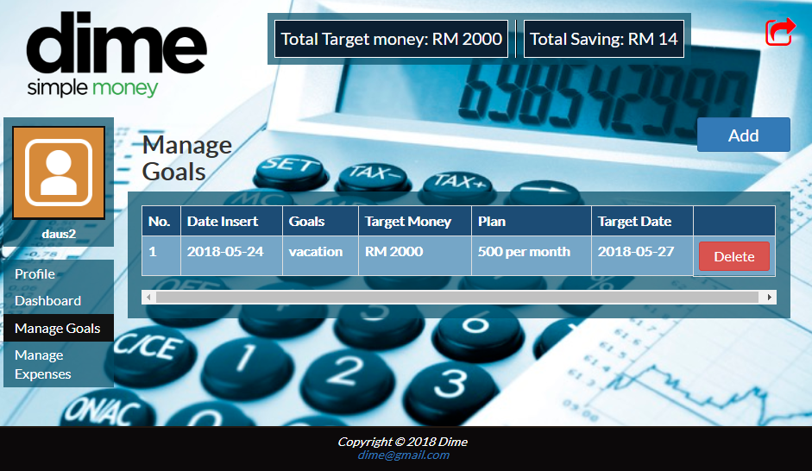

**Figure 8**

Figure 8 shows the manage goals page. In this page user can manage their goals, user can add and delete goals. User can enter their targeted money of the month and what is it for. User can see their goal whenever they open the Manage Goals feature.

* + - 1. **Add, Edit, Delete Goals**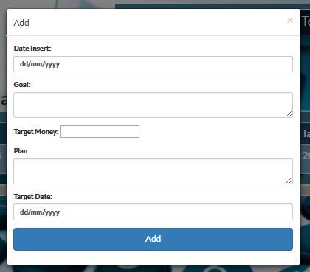

Figure 9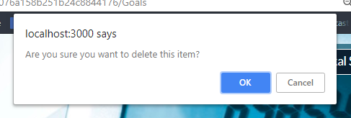

Figure 10



Figure 9 shows is the form that is need to be enter to display the goals in Figure 8. User need to fill the form and when the form is completed user only need to click the add button. The data that need to be complete are Date Insert, Goal, Target money, Plan and Target date For the delete button user will be notify first if he/she want to delete the goal. The delete goals will be delete permanently.

* + 1. **Manage Expenses**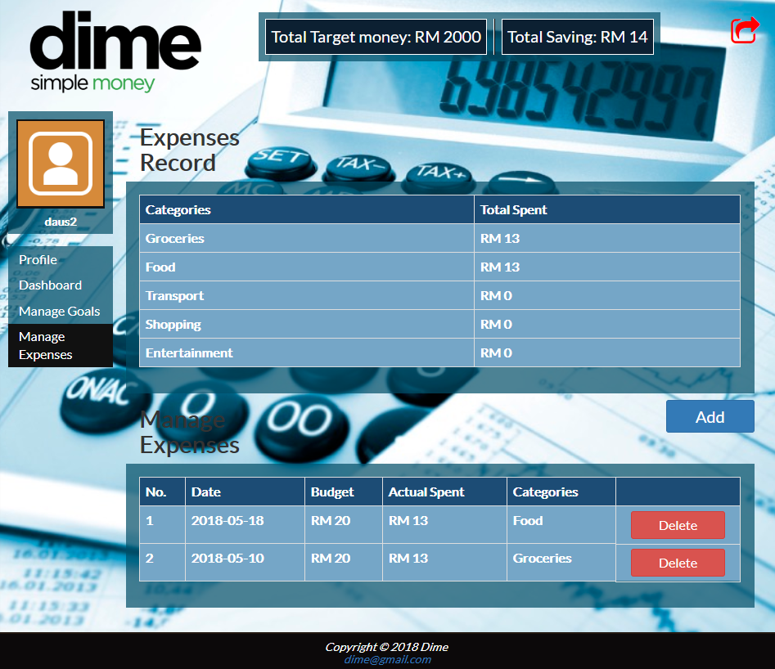

**Figure 9**

Figure 9 shows the Manage Expense page ,here user can manage their expenses according to budget and actual spending. In this section user can add and delete according to their own category. The total spent will be generate according to the data that has been input which are amount of spending and budget. Then, the total amount of spending will be shown.

* + - 1. **Add, Edit, Delete Expenses**

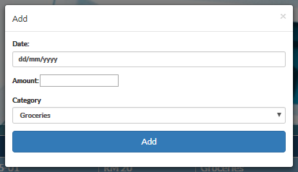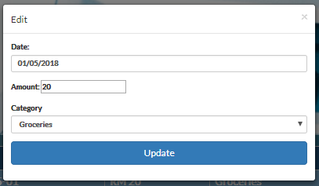

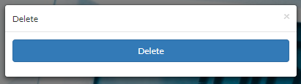

Figure 10, 11 is add and Edit form consist of 3 input field for user to insert the date, amount and the category of expenses, and Figure 12 got a delete button to delete the expenses. In add button the data that must need to input are Date, Amount and category. For update part data that need to input are Date, amount and category. The variable will be update according to the user input. Lastly, user can delete the item they wish to delete.

* + 1. **LOG OUT**

**Figure 13**

Figure 10 show to LOGOUT button at top right corner of the window, we make it in red colour to make it more distinguishable by the user. When the user click that red button, they will immediately go to the index tab window and they need to re login if they want to use this web application.

1. **REPORT**
   1. **Report Capabilities**

Based on Figure 4,5,9 the information that key in by the user is shown in the table and chart. The figure was shown in summary report in form of graph and chart. Thus it make user easier to see the amount of their expense according to its category, actual expense and budget. In Figure 4 the total expense Is shown in Chart form ,that derived from Expenses Record from Figure 9.In Figure 5 the Manage Goals information table is shown to make it easier to user to follow up their goals.